
Psychology
Department

A Level Psychology Induction Task
STUDENT NAME: [Enter your name here]

Psychology is the scientific study of behaviour. The aim of Psychology is to attempt to explain how and why we think, feel and behave as we do. Psychologists do this by formulating theories to explain the given behaviour. Psychology is regarded as a science because once Psychologists have formulated their theories they then design and conduct scientific research studies to test whether these theories are valid. Studying Psychology will involve learning about the theories and studies of many established Psychologists. The following information will introduce the type of content and tasks you will complete in Psychology.

1. Read the following information about some different approaches in Psychology.

An approach in Psychology is a way of explaining behaviour. Explanations often are derived from one of the main approaches in Psychology of which there are many.

The Behavioural Approach is part of the overall Learning approach. These Psychologists would suggest that when we are born we are a ‘blank slate’ and that we ‘learn’ to behave in certain ways depending on how we are rewarded or punished for our actions. If a person’s behaviour is rewarded in some way that person will continue to behave in that way, however if the same behaviour is punished then the person is less likely to repeat the behaviour in the future. Furthermore some behaviourist psychologists would suggest we can also learn behaviours by watching other people being rewarded or punished.

A second approach in Psychology is the Biological Approach. This approach claims that our behaviour is a direct result of one of our physiological processes. These include our genes, biochemistry, brain structure or possibly even contraction of an infection. Genetic explanations would suggest that our behaviour is inherited from the genes passed on from our parents. Biochemical explanations would suggest that changes in our biological chemicals, such as our hormones or neurotransmitters, can explain our behaviour. Brain structure explanations would suggest that our behaviours are a result of the activation of certain areas of the brain. Finally infection explanations would claim viral or bacterial contamination can explain our behaviour.

Thirdly, the Cognitive approach advocates the importance of thought (mental) processes in explaining human behaviour. The cognitive approach believes that the study of thought processes should be carried out scientifically rather than just asking participants for their subjective viewpoint. They argue that although the thought processes are not directly observable they can be studied by making inferences about thoughts people are experiencing. An important concept within this approach are Schemas. These are packages of knowledge about certain situations or people, which are built through experiences and interactions with our environment eg a “classroom” schema so that you knew how to behave on entry to your classroom.
The fourth approach you will experience is the Psychodynamic approach. It emphasises unconscious processes, that operate within the mind and direct human behaviour and experience. It also emphasises instincts or drives that motivate our behaviour, and that early childhood is pivotal in making us the person that we are. Some parts of our personality exist within our unconscious such as our selfish, pleasure seeking part known as the Id and our moral conscience that can make us feel guilty known as the superego.
Finally, the Humanistic approach focuses on explanations of ‘healthy’ growth in individuals and stresses uniqueness and free will. It believes we all have an innate tendency to strive for self actualisation, to achieve all we are capable of in life. It is a less scientific approach than the biological or behavioural.

2. Restricting yourself to 6 words for each approach, which would you consider to be the most important key terms for each approach?

3. We study the topic of Aggression during the A level.
In a previous European football championship, Russian fans provoked and attacked other fans on numerous occasions, in particular the England supporters.
How would each of the approaches explain the above? Which is the best explanation?

4. Now read the following research study and research findings of Sarason and Sarason.

Sarason and Sarason compared the concordance rates of 17 monozygotic twin pairs (identical twins who share 100% of their genetic makeup) and 15 dizygotic twin pairs (non-identical twins who share around 50% of their genetic makeup) for several psychological disorders. Concordance rates are essentially similarity rates looking at how frequently both twins within the pair suffer from the same psychological disorder. If the concordance rate is 100% then all the twin pairs in the sample both suffered from the same psychological disorder. A graph illustrating their findings is below.

A graph showing the concordance rates for psychological disorders across monozygotic and dizygotic twins
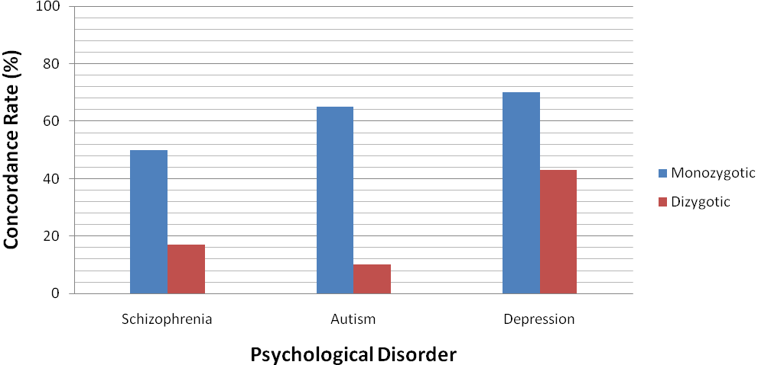
5. The research by Sarason and Sarason was investigating the contribution of genetic factors in the onset of psychological disorders.
i) Using the data in the graph, summarise (in your own words) what the research findings of Sarason and Sarason show.
ii) Explain what these findings suggest about the contribution of genetic to psychological disorders.

6. Can you think of any problems of using twins to determine whether genetic factors cause the onset of psychological disorders? Explain your answer.

